Data cleaned:

library(dplyr)

library(ggplot2)

# Remove rows with a year greater than 2024

ford <- ford %>%

filter(year <= 2024)

EDA:

# Histogram of Prices

ggplot(ford, aes(x = price)) +

geom_histogram(bins = 30, fill = "blue", color = "black") +

ggtitle("Distribution of Prices") +

xlab("Price") +

ylab("Frequency")

# Histogram of Mileage

ggplot(ford, aes(x = mileage)) +

geom_histogram(bins = 30, fill = "green", color = "black") +

ggtitle("Distribution of Mileage") +

xlab("Mileage") +

ylab("Frequency")

# Histogram of Vehicle Age

ford <- ford %>% mutate(age = 2024 - year) # Calculating age of the vehicles

ggplot(ford, aes(x = age)) +

geom_histogram(bins = 30, fill = "red", color = "black") +

ggtitle("Distribution of Vehicle Age") +

xlab("Age (years)") +

ylab("Frequency")

# Scatter Plot: Price vs. Mileage

ggplot(ford, aes(x = mileage, y = price)) +

geom_point(alpha = 0.5) +

geom_smooth(method = "lm", se = FALSE, color = "blue") +

ggtitle("Price vs. Mileage") +

xlab("Mileage") +

ylab("Price")

# Scatter Plot: Price vs. Age

ggplot(ford, aes(x = age, y = price)) +

geom_point(alpha = 0.5) +

geom_smooth(method = "lm", se = FALSE, color = "red") +

ggtitle("Price vs. Age") +

xlab("Age (years)") +

ylab("Price")

Add age column:

current_year <- 2024

ford_clean$age <- current_year - ford_clean$year

library(MASS)

# Determine best lambda for Box-Cox Transformation

bc <- boxcox(price ~ mileage + age, data = ford_clean, lambda = seq(-2, 2, by = 0.1))

best_lambda <- bc$x[which.max(bc$y)]

# Transform the price

ford_clean$price_transformed <- (ford_clean$price^best_lambda - 1) / best_lambda

library(glmnet)

> x <- model.matrix(~ mileage + age, data = ford_clean)

> y <- ford_clean$price_transformed

>

> # Fit Ridge regression model

> ridge_model <- glmnet(x, y, alpha = 0, lambda = 10^seq(4, -2, length = 100))

> plot(ridge_model)

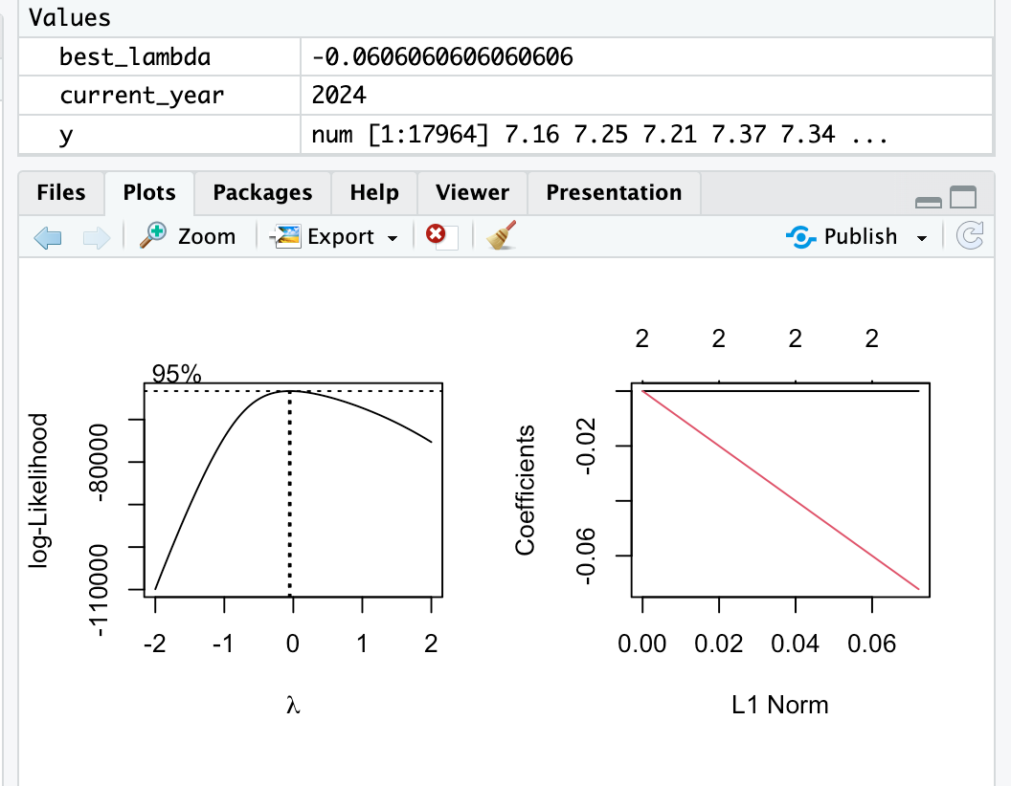

WLS

weights <- 1 / ford_clean$age

> wls_model <- lm(price_transformed ~ mileage + age, data = ford_clean, weights = weights)

> summary(wls_model)

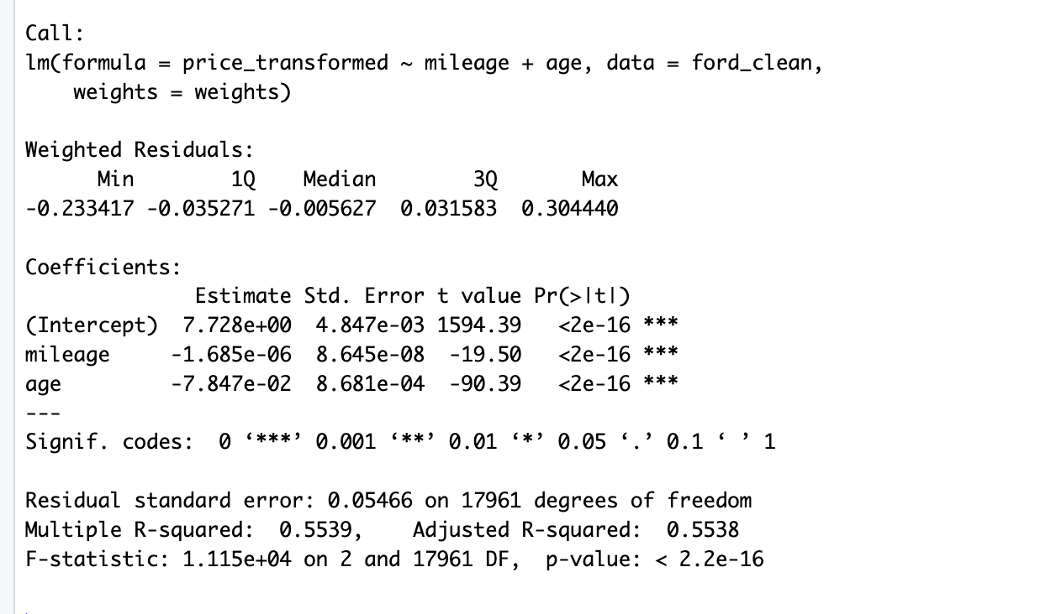

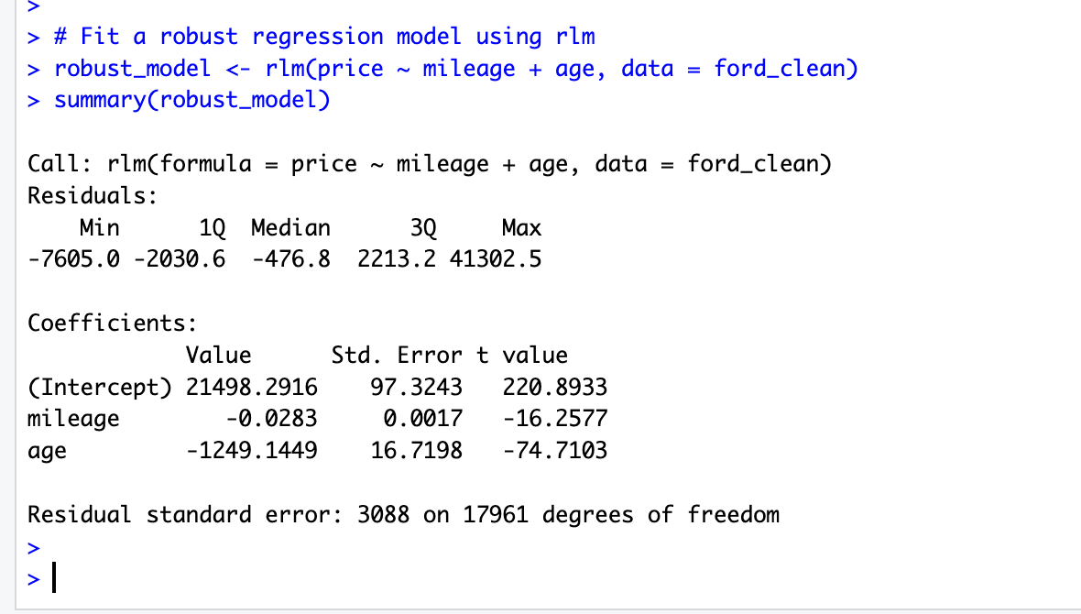

# Fit a robust regression model

> robust_model <- rlm(price ~ mileage + age, data = ford_clean)

> summary(robust_model)

Hypothesis testing:

Finding best lambda for ridge:

library(glmnet)

cv_ridge <- cv.glmnet(x, y, alpha = 0)

best_lambda_ridge <- cv_ridge$lambda.min

ridge_model <- glmnet(x, y, alpha = 0, lambda = best_lambda_ridge)

#Ridge regression results

coef(ridge_model, s = "0.018090048613303")

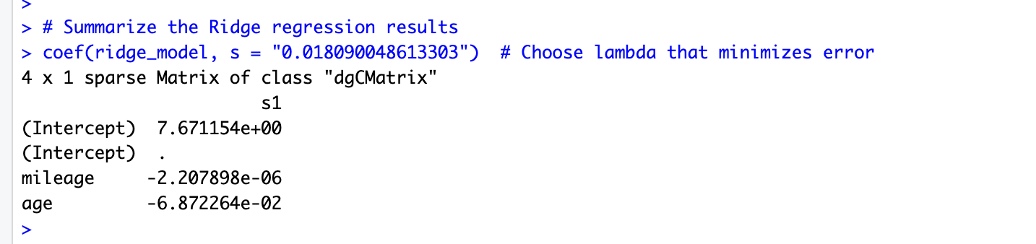

# Summary of WLS model

summary(wls_model)

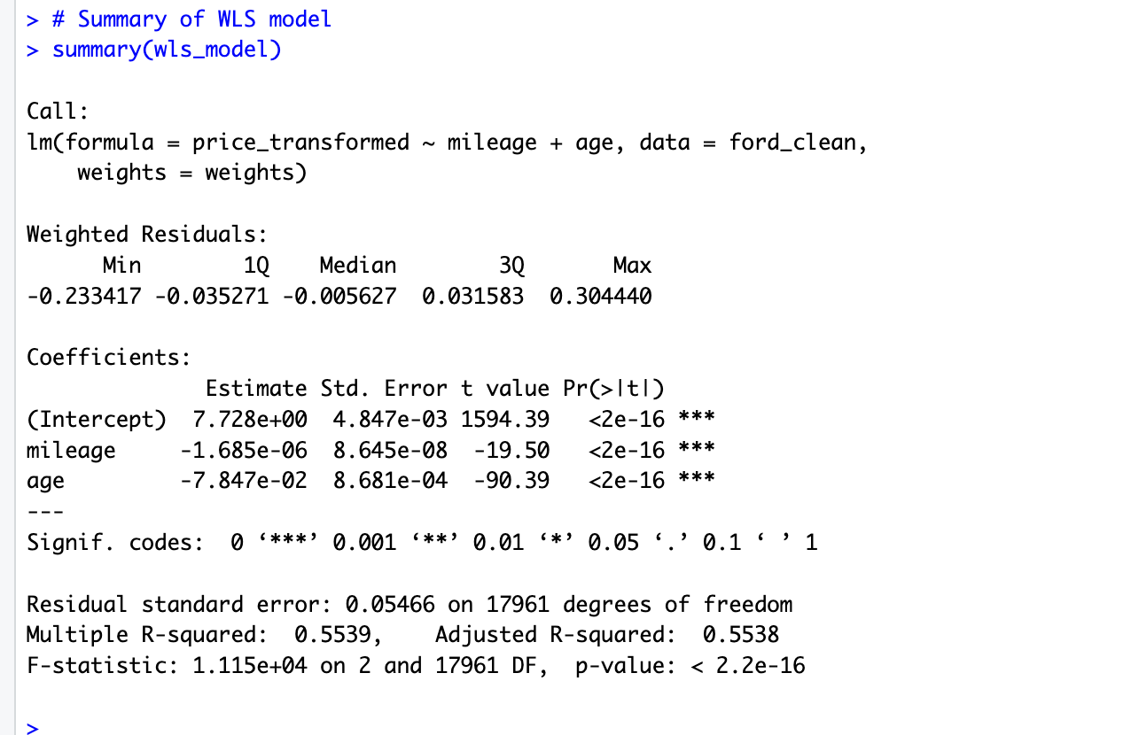

# Summary of robust model

summary(robust_model)

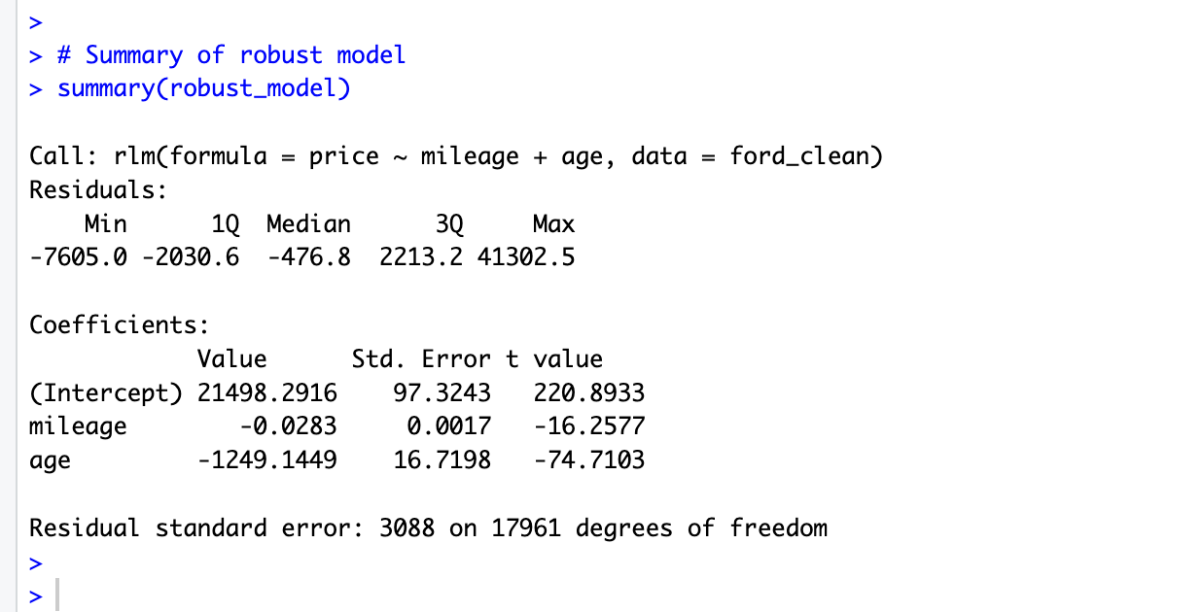

# Breusch-Pagan test for heteroscedasticity

> bptest(wls_model)

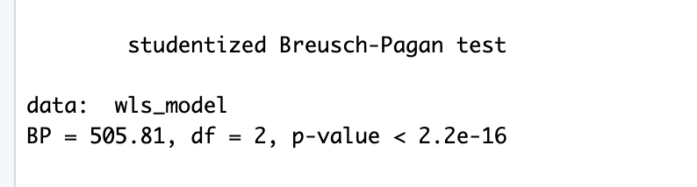

> # Shapiro-Wilk test for normality of residuals

> shapiro.test(residuals(wls_model))

> shapiro.test(sample(residuals(wls_model),5000))

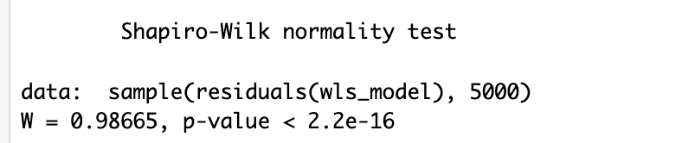

# Diagnostic plots

> par(mfrow = c(2, 2))

> plot(wls_model)

10 fold cross validation

train.control <- trainControl(method="cv", number = 10)

> cv.model <- train(price ~ age + mileage, data = ford_clean,

+ method = "lm",

+ trControl = train.control)

> print(cv.model)

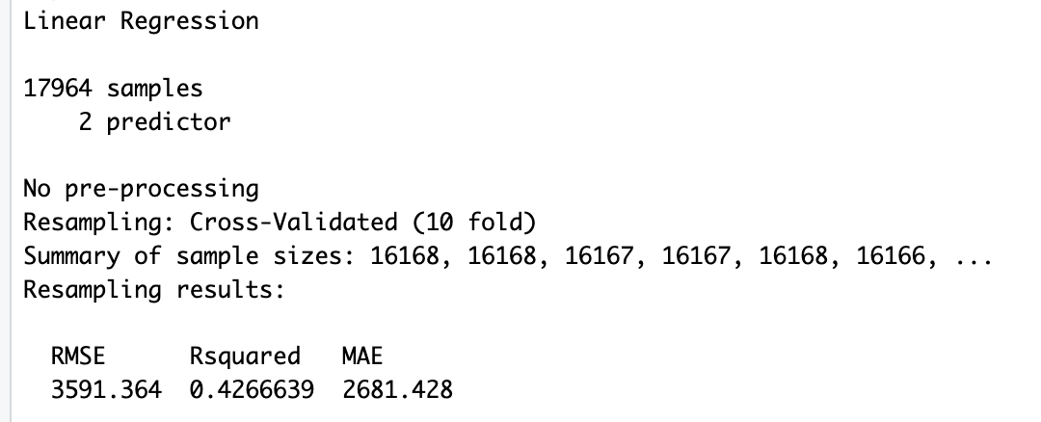

Cross validation on box cox transformed price

> train.control <- trainControl(method="cv", number = 10)

> cv.model <- train(price_transformed ~ age + mileage, data = ford_clean,

+ method = "lm",

+ trControl = train.control)

> print(cv.model)

